**DBMS LAB MANUAL**

**Name: Mymoon Beevi.B Roll No: 230701201**

**Ex No: 3**

**Writing Basic SQL statements**

1. Desc department;

2. Select employee_id, last_name, job_id, hire_date from employees;

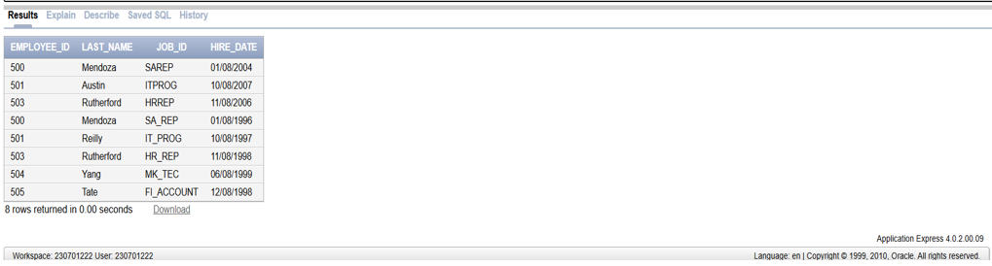

3. select hire_date as startdate from employees;

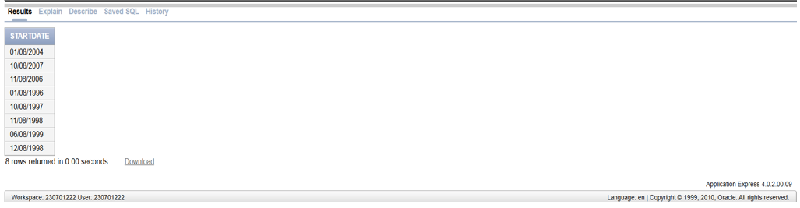

4. Select DISTINCT job_id from employees;

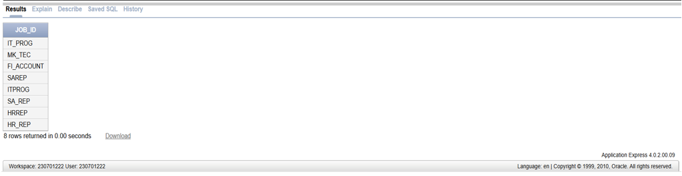

5. Select Last_name ||’,’|| Job_id as “Employee title” from employees;

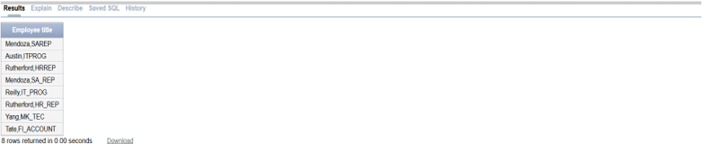

6. Select employee_id ||’,’|| first_name ||’,’|| last_name ||’,’|| email ||’,’|| phone_number ||’,’|| hire_data ||’,’|| Job_id ||’,’|| salary ||’,’|| commission_pct ||’,’|| manager_id ||’,’|| department_id as “THEOUTPUT” from employees;

